Pac-Poly-Hi-Hi Cooke-1784

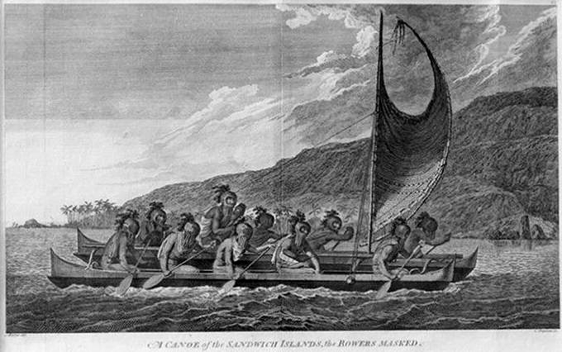

John Webber Copperplate Etching 'A CANOE OF THE SANDWICH ISLANDS, the ROWERS MASKED' - from CAPTAIN COOK Voyages

Plate 65 from one of the later edition Atlases Accompanying Capt. James Cook and King; Third & Final voyage of Captain James Cook.

This image depicts priests traveling across Kealakekua bay for first contact rituals. Each helmet is a gourd, with foliage and tapa strip decoration. A feather-surrounded akua is in the arms of the priest at the center of the engraving.

Engraved by C. Grignion, drawing by John Webber.

  Captain Cook's  1776–1780 Expedition consisted of two ships, the Resolution and the Discovery and 182 men. They were charged by the British Admiralty to search for a Northwest Passage from the western coast of North America. On this voyage, Cook discovered the Hawaiian Islands, was the first to chart Alaska’s southern coastline, and reached farther north than any previous Pacific mariner.  *"A Voyage to the Pacific Ocean. Undertaken, by the Command of His Majesty, for Making Discoveries in the Northern Hemisphere, to Determine the Position and Extent of the West Side of North America; Its Distance from Asia; and the Practicability of a Northern Passage to Europe. Performed under the Direction of Captains Cook, Clerke, and Gore, in His Majesty’s Ships the Resolution and Discovery, in the Years 1776, 1777, 1778, 1779, and 1780,"* was the first official publication of Cook’s third voyage with its folio atlas. It was so eagerly awaited by the public that it sold out in three days.

***"I had no where, in the course of my voyages, seen so numerous a body of people assembled at one place. . . . To this disappointment [not finding a Northwest Passage] we owed our having it in our power to revisit the Sandwich Islands, and to enrich our voyage with a discovery which, though the last, seemed, in many respects, to be the most important that had hitherto been made by Europeans, throughout the extent of the Pacific Ocean."  [Cook, vol. 2, p. 549]***

* Artist: John Webber
* Engraver: C. Grignion
* Condition is very good, with some creasing in the print (see photos). The image has not been trimmed and is a full page from one of the later edition voyage atlases as published!
* Vintage silver frame is included
* Image Size with frame: 22" x 16.5"
* Actual print size: 15.2" x 10"

=========================================================================

1784 FIRST EDITION Webber Copperplate Etching 'TEREOBOO, KING of OWYHEE, bringing PRESENTS TO CAPT COOK' - from CAPTAIN COOK Voyages

Plate 61 from the 1784 First Edition Atlas Accompanying Capt. James Cook and King; Third and Final Voyage of Captain James Cook. $1,595.00

On 8 January 1784, Captain James Cook wrote to Dr. Douglas, the editor:

"On examining the prints, I found that No. 61, "Terreoboo bringing presents to Capt. Cook" has not quite its right title. It is intended to represent the ceremony of Terreoboo's rowing around the ships the day after his arrival, to prevent mistakes therefore would it not be proper to add the following note: "This curious ceremony is represented in the annexed engraving. The presents mentioned in the title were made to Capt. Cook after he came on shore." Cook/King (1784)

  Captain Cook's 1776–1780 Expedition consisted of two ships, the Resolution and the Discovery and 182 men. They were charged by the British Admiralty to search for a Northwest Passage from the western coast of North America. On this voyage, Cook discovered the Hawaiian Islands, was the first to chart Alaska’s southern coastline, and reached farther north than any previous Pacific mariner.  "A Voyage to the Pacific Ocean. Undertaken, by the Command of His Majesty, for Making Discoveries in the Northern Hemisphere, to Determine the Position and Extent of the West Side of North America; Its Distance from Asia; and the Practicability of a Northern Passage to Europe. Performed under the Direction of Captains Cook, Clerke, and Gore, in His Majesty’s Ships the Resolution and Discovery, in the Years 1776, 1777, 1778, 1779, and 1780," was the first official publication of Cook’s third voyage with its folio atlas. It was so eagerly awaited by the public that it sold out in three days.

• Artist: John Webber

• Engraver: B.T. Pouncy

• Condition is excellent for a original work of art that is 229 years old (see photos). Also the image has not been trimmed and is a full page from the third voyage atlas as published!

• Image Size: 16" x 10"

• Mat Size: 24" x 20"

SHAPE \* MERGEFORMAT 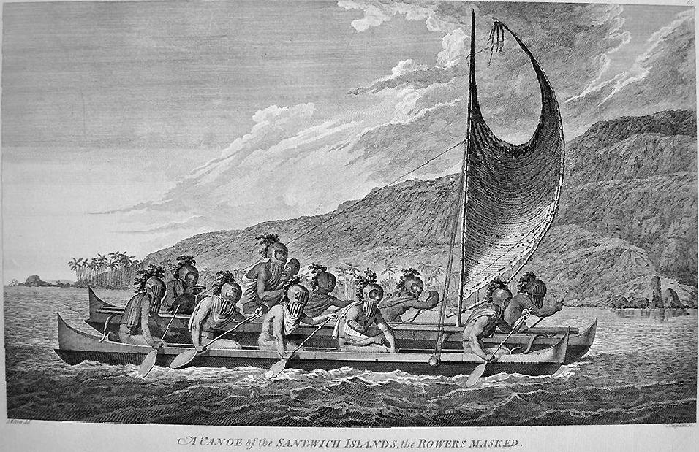 1784 FIRST EDITION Webber Copperplate Etching 'A CANOE OF THE SANDWICH ISLANDS, the ROWERS MASKED' - from CAPTAIN COOK Voyages

Plate 65 from the 1784 First Edition Atlas Accompanying Capt. James Cook and King; Third and final voyage of Captain James Cook.

This image depicts priests traveling across Kealakekua bay for first contact rituals. Each helmet is a gourd, with foliage and tapa strip decoration. A feather-surrounded akua is in the arms of the priest at the center of the engraving.

Engraved by C. Grignion, drawing by John Webber.

  Captain Cook's  1776–1780 Expedition consisted of two ships, the Resolution and the Discovery and 182 men. They were charged by the British Admiralty to search for a Northwest Passage from the western coast of North America. On this voyage, Cook discovered the Hawaiian Islands, was the first to chart Alaska’s southern coastline, and reached farther north than any previous Pacific mariner.  *"A Voyage to the Pacific Ocean. Undertaken, by the Command of His Majesty, for Making Discoveries in the Northern Hemisphere, to Determine the Position and Extent of the West Side of North America; Its Distance from Asia; and the Practicability of a Northern Passage to Europe. Performed under the Direction of Captains Cook, Clerke, and Gore, in His Majesty’s Ships the Resolution and Discovery, in the Years 1776, 1777, 1778, 1779, and 1780,"* was the first official publication of Cook’s third voyage with its folio atlas. It was so eagerly awaited by the public that it sold out in three days.

***"I had no where, in the course of my voyages, seen so numerous a body of people assembled at one place. . . . To this disappointment [not finding a Northwest Passage] we owed our having it in our power to revisit the Sandwich Islands, and to enrich our voyage with a discovery which, though the last, seemed, in many respects, to be the most important that had hitherto been made by Europeans, throughout the extent of the Pacific Ocean."  [Cook, vol. 2, p. 549]***

* Artist: John Webber
* Engraver: C. Grignion
* Condition is excellent for a original work of art that is 229 years old (see photos). Also the image has not been trimmed and is a full page from the third voyage atlas as published!
* Image Size: 16" x 10"
* Mat Size: 24" x 20"

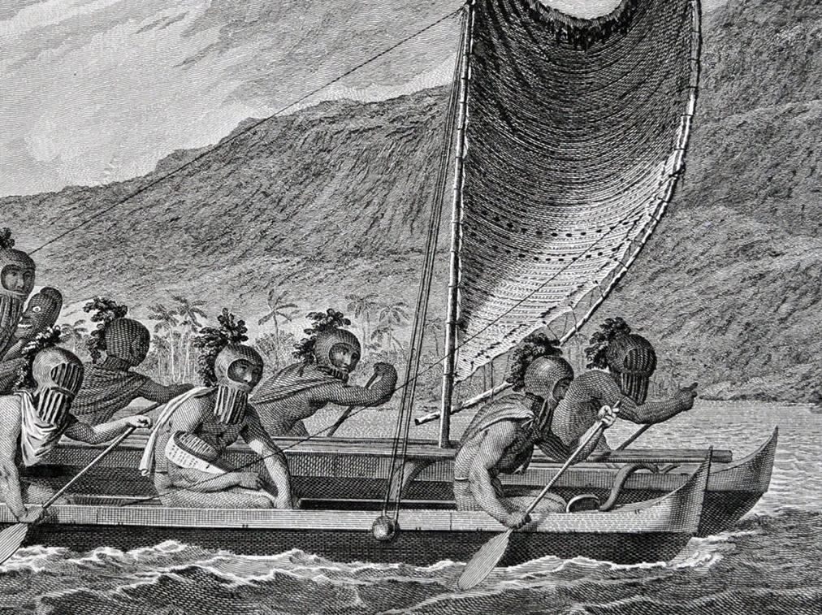

SHAPE \* MERGEFORMAT 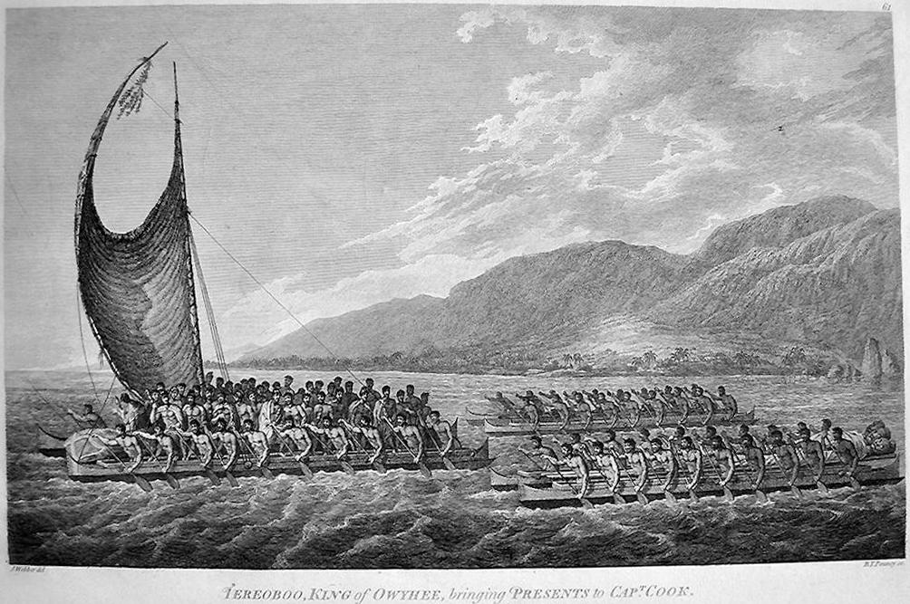

1784 FIRST EDITION Webber Copperplate Etching 'THE INSIDE of the HOUSE, in the MORAI in ATOOL' - from CAPTAIN COOK Voyages

Plate 34 from the 1784 First Edition Atlas Accompanying Capt. James Cook and King; Third and final voyage of Captain James Cook.

  Captain Cook's  1776–1780 Expedition consisted of two ships, the Resolution and the Discovery and 182 men. They were charged by the British Admiralty to search for a Northwest Passage from the western coast of North America. On this voyage, Cook discovered the Hawaiian Islands, was the first to chart Alaska’s southern coastline, and reached farther north than any previous Pacific mariner.  *"A Voyage to the Pacific Ocean. Undertaken, by the Command of His Majesty, for Making Discoveries in the Northern Hemisphere, to Determine the Position and Extent of the West Side of North America; Its Distance from Asia; and the Practicability of a Northern Passage to Europe. Performed under the Direction of Captains Cook, Clerke, and Gore, in His Majesty’s Ships the Resolution and Discovery, in the Years 1776, 1777, 1778, 1779, and 1780,"* was the first official publication of Cook’s third voyage with its folio atlas. It was so eagerly awaited by the public that it sold out in three days.

***"I had no where, in the course of my voyages, seen so numerous a body of people assembled at one place. . . . To this disappointment [not finding a Northwest Passage] we owed our having it in our power to revisit the Sandwich Islands, and to enrich our voyage with a discovery which, though the last, seemed, in many respects, to be the most important that had hitherto been made by Europeans, throughout the extent of the Pacific Ocean."  [Cook, vol. 2, p. 549]***

* Artist: John Webber
* Engraver: Scott
* Condition is excellent for a original work of art that is 229 years old (see photos). Also the image has not been trimmed and is a full page from the third voyage atlas as published!
* Image Size: 11" x 9"
* Mat Size: 24" x 20"

SHAPE \* MERGEFORMAT 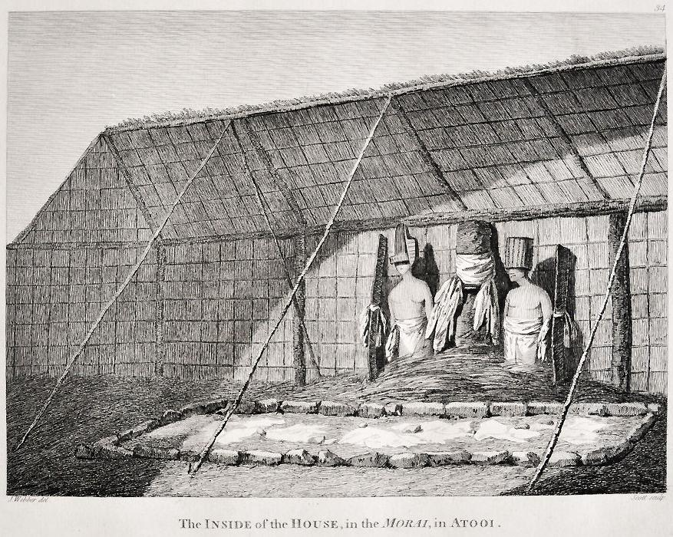

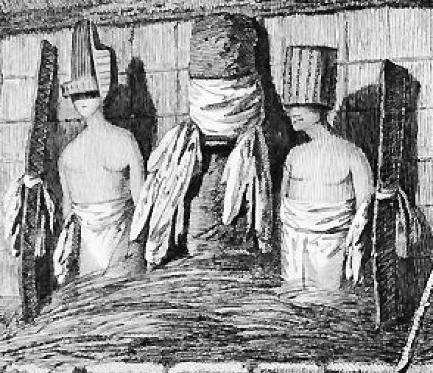 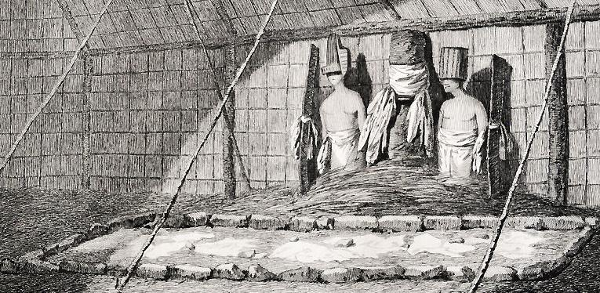v 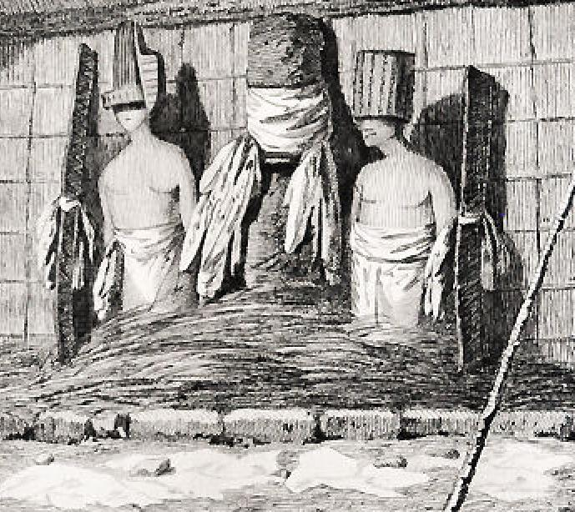

1784 FIRST EDITION Webber Copperplate Etching 'AN OFFERING before CAPT COOK, in the SANDWICH ISLANDS' - from CAPTAIN COOK Voyages

Plate 60 from the 1784 First Edition Atlas Accompanying Capt. James Cook and King; Third and Final Voyage of Captain James Cook.

 Captain Cook's 1776–1780 Expedition consisted of two ships, the Resolution and the Discovery and 182 men. They were charged by the British Admiralty to search for a Northwest Passage from the western coast of North America. On this voyage, Cook discovered the Hawaiian Islands, was the first to chart Alaska’s southern coastline, and reached farther north than any previous Pacific mariner.  *"A Voyage to the Pacific Ocean. Undertaken, by the Command of His Majesty, for Making Discoveries in the Northern Hemisphere, to Determine the Position and Extent of the West Side of North America; Its Distance from Asia; and the Practicability of a Northern Passage to Europe. Performed under the Direction of Captains Cook, Clerke, and Gore, in His Majesty’s Ships the Resolution and Discovery, in the Years 1776, 1777, 1778, 1779, and 1780,"* was the first official publication of Cook’s third voyage with its folio atlas. It was so eagerly awaited by the public that it sold out in three days.

***"I had no where, in the course of my voyages, seen so numerous a body of people assembled at one place. . . . To this disappointment [not finding a Northwest Passage] we owed our having it in our power to revisit the Sandwich Islands, and to enrich our voyage with a discovery which, though the last, seemed, in many respects, to be the most important that had hitherto been made by Europeans, throughout the extent of the Pacific Ocean."  [Cook, vol. 2, p. 549]***

• Artist: John Webber

• Engraver: J. Hall & S. Middiman

• Condition is excellent for a original work of art that is 229 years old (see photos). Also the image has not been trimmed and is a full page from the third voyage atlas as published!

• Image Size: 16" x 10"

• Mat Size: 24" x 20"

